Hi Julia,

I would like to thank you for providing such a good platform to improve my experience and skillset. I have outlined your main tasks along with what we should be looking for in the data for each.

**Examine transaction data** –

* Client has selected store numbers 77, 86 and 88 as trial stores.
* Client wants control stores to be established stores that are operational for the entire observation period.
* Trial period = 1 Feb 2019 to 30 April 2019.
* Compare trial stores to control stores that are similar pre-trial. Similarity measurement:
  + Monthly overall sales revenue
  + Monthly number of customers
  + Monthly number of transactions per customer

**Examine customer data**

|  | **YEARMONTH** | **Trial_Str** | **Ctrl_Str** | **Corr_Score** |  |
| --- | --- | --- | --- | --- | --- |
| **0** | 201807 | 77 | 1 | 0.070414 |  |
| **1** | 201808 | 77 | 1 | 0.027276 |  |
| **2** | 201809 | 77 | 1 | 0.002389 |  |
| **3** | 201810 | 77 | 1 | -0.020045 | Negative Correlation |
| **4** | 201811 | 77 | 1 | 0.030024 |  |
| **5** | 201812 | 77 | 1 | 0.063946 |  |
| **6** | 201901 | 77 | 1 | 0.001470 |  |
| **0** | 201807 | 77 | 2 | 0.142957 |  |

**Data analysis and customer segments**

1. **Top 3 similarity based on TOT_SALES:**

* Trial store 77: Store 233, 255, 188
* Trial store 86: Store 109, 155, 222
* Trial store 88: Store 40, 26, 72

1. **Top 3 similartiy based on nCustomers:**

* Trial store 77: Store 233, 41, 111
* Trial store 86: Store 155, 225, 109
* Trial store 88: Store 237, 203, 40

1. **Based on highest average of both features combined:**

* Trial store 77: Store 233
* Trial store 86: Store 155
* Trial store 88: Store 40

**Deep dive into customer segments** –

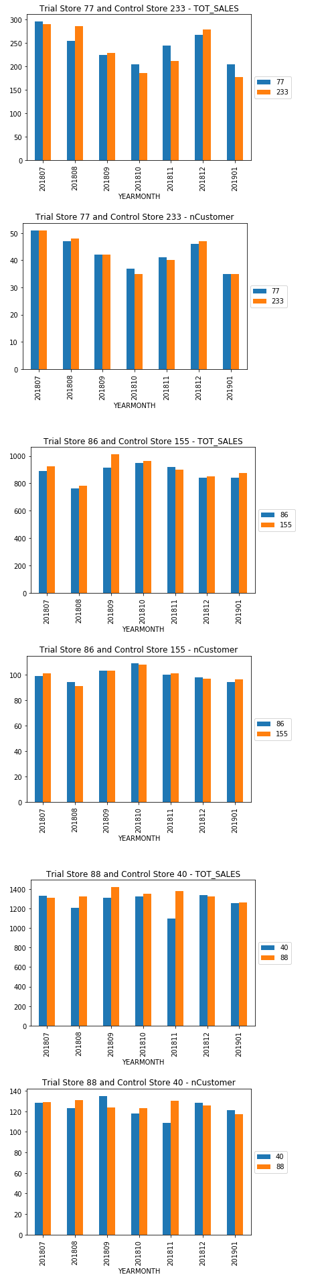

I have saved and provided the notebook files and visualizations for your evaluation along with the PDF Document.

Thanks and Regards

Arvind S